 |  |  |  |  |  |  |  |  |  |  |  |  |  |  | 
 | RESERVE BANK OF INDIA
 | Form for Annual Return on Foreign Liabilities and Assets
 |  |  |  |  |  |  |  |  |  |  |  |  |  |  | as on 31 March, |  |  | Y Y Y Y
 | (Return to be filled under A.P. (DIR Series) Circular No.145 dated June 18, 2014
 | to the Department of Statistics and Information Management, RBI, Mumbai)
 | Tips while filling the form: Use [Tab] or [Enter]to navigate through the fields while filling the form.
 |  |  | Please enable the macro as provided below to use the complete functionality;
 |  |  | -- For Win 98/ 2000 / ME / XP or below version of Ms office.
 |  |  |  | Click on the "Enable Macro" button while opening the file.
 |  |  | -- For 2007 / 2010 or above version of Ms office.
 |  |  |  | Click on the "Option" button just below the menu bar as shown in snap shot below.
 |  |  |  | 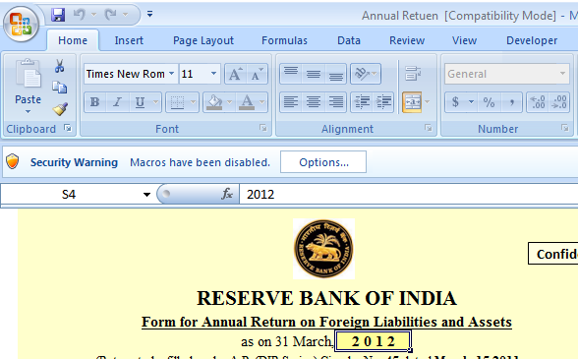
 |  |  | - If you are unable to run the macro, please re-open the file and enable the macro.
 | Click on 'View buttons' below if you want to see the form or click on 'Start filling the form' button to fill the form.
 |  |  |  |  |  |  |  |  |  |  |  | View Button
 |  |  |  |  |  |  |  |  |  |  |  |  |  |  |  |  |  |  |  |  |  |  | 
 | Note: You can only view the form using view buttons. Click on 'Start filling the form >>' button to fill the form.

